Memorandum
Date: August 2022
To: FCCLA Chapter Advisors and Chapter Presidents
From: 2022–2023 FCCLA State Officers and
Melissa Webb, FCCLA State Advisor
Subject: FCCLA Program Information for 2022–2023 Program Year:
Students Taking Action with Recognition (STAR) Competitors
Welcome to the 2022–2023 program year! This year marks 76 years of leadership and career development opportunities provided by California FCCLA. A strong state association depends on the active involvement and support of the members, officers, and advisors. Your role as either an Advisor or Chapter President is critical in helping members actively participate in and achieve life/career goals through FCCLA.
The enclosed materials contain important information that chapters will need to prepare for a successful year, including planning an effective chapter program of work, recognizing members and advisors, and participation in leadership and career development activities. As student and adult FCCLA leaders at the local level, please carefully review and inform your members of the exciting opportunities available for involvement and recognition so that your chapter can fully benefit from the FCCLA experience. For easy reference, we suggest that you put this packet and other mailings and email messages you receive during the year in a binder.
The theme “incredible leaders” recognizes and celebrates our members’ accomplishments through FCCLA. This theme highlights the opportunities that FCCLA offers, embraces experiences, and builds self-esteem. The 2022–2023 State Officers are challenging members to make their participation in FCCLA count and have identified the following goals for the year:
- Membership – Make membership incredible by encouraging all chapters to opt into 100% affiliation to reach the membership goal of 20,000 members.
- Leadership – Make leadership incredible by having a minimum of two students per chapter run for Region Office and two students per region run for State Office.
- Engagement – Make engagement incredible by getting members more involved and double the number of competitors at the 2023 State Leadership Conference.
- Outreach– Make outreach incredible by promoting FCCLA through positive experiences. Share and repost all accomplishments through every social media platform.
CA FCCLA: incredible leaders! We invite you and your chapter to start planning for your active involvement. With your assistance, this year will be one of growth, achievement, and increased participation in FCCLA at all levels of the association. If you have any questions, please contact Melissa Webb at mwebb@cde.ca.gov.

Best wishes for a great year in FCCLA from your 2022-2023 FCCLA State Officer Team!

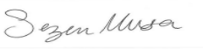 | 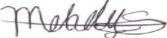 |  | 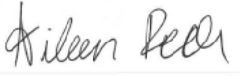 |  | 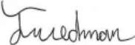  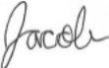 | 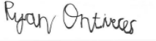
President | Vice President and Reporter |  | Secretary |  | Treasurer | Historian

Melissa Webb, FCCLA State Advisor

